Q-7-1

1) Monthly snowfall (in inches) was measured over several winters in Fort Collins, Colorado. Researchers also recorded whether the measurement was taken in the Early winter (September to December) or Late winter (January to June). Boxplots displaying the distribution of monthly snowfall for each season are below.
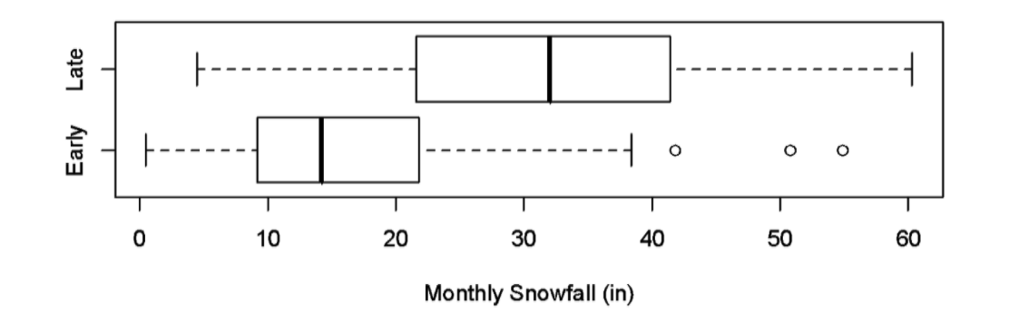
The shape of the distribution of monthly snowfall measurements for the Early season is
a. symmetric.
b. skewed right.
c. skewed left.
d. bimodal.

2) Monthly snowfall (in inches) was measured over several winters in Fort Collins, Colorado. Researchers also recorded whether the measurement was taken in the Early winter (September to December) or Late winter (January to June). Boxplots displaying the distribution of monthly snowfall for each season are below.
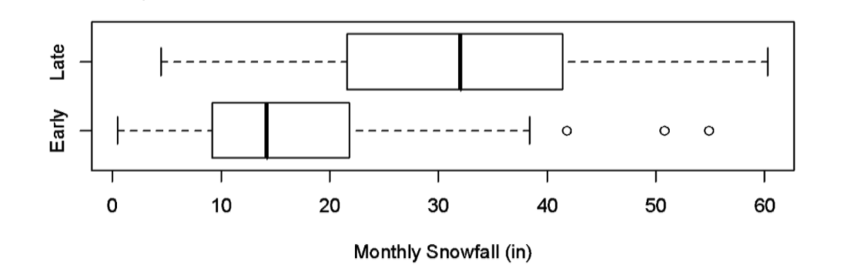
What is the upper quartile (Q3) of the distribution of monthly snowfall measurements for the Late season (approximately)?
a. 22
b. 33
c. 41
d. 60

3) Monthly snowfall (in inches) was measured over several winters in Fort Collins, Colorado. Researchers also recorded whether the measurement was taken in the Early winter (September to December) or Late winter (January to June). Boxplots displaying the distribution of monthly snowfall for each season are below.
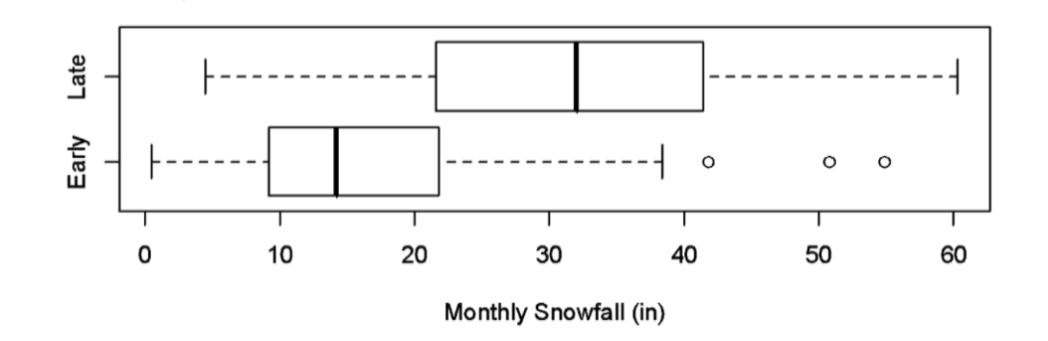
Which of the following sentences correctly interprets the first quartile (Q1) of the distribution of monthly snowfall measurements for the Early season?
a. About 25% of Early season winter months in Fort Collins get less than 9 inches of snow.
b. About 50% of Early season winter months in Fort Collins get less than 9 inches of snow.
c. About 75% of Early season winter months in Fort Collins get less than 9 inches of snow.
d. About 25% of Early season winter months in Fort Collins get more than 38 inches of snow.

4) Monthly snowfall (in inches) was measured over several winters in Fort Collins, Colorado. Researchers also recorded whether the measurement was taken in the Early winter (September to December) or Late winter (January to June). Boxplots displaying the distribution of monthly snowfall for each season are below.
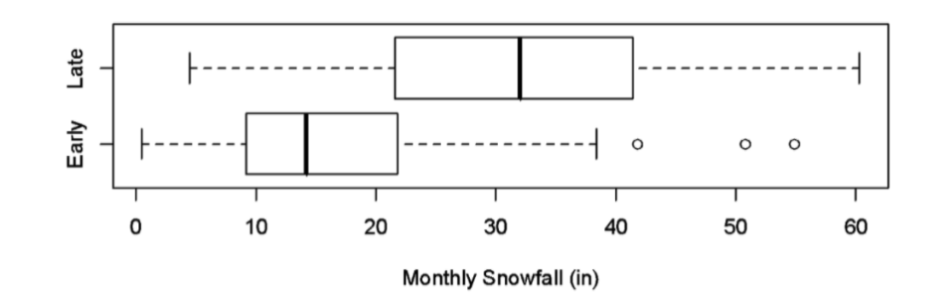
Which season has the larger median monthly snowfall?
a. Early
b. Late
c. The two medians are approximately equal.
d. The plot does not provide enough information to determine which median is larger.

5) Which of the following data sets has the largest standard deviation?
a. 1, 2, 3, 4, 5
b. 1, 3, 3, 3, 5
c. 1, 1, 3, 5, 5
d. 1, 1, 1, 1, 1

6) Monthly snowfall (in inches) was measured over several winters in Fort Collins, Colorado. Researchers also recorded whether the measurement was taken in the Early winter (September to December) or Late winter (January to June). Boxplots displaying the distribution of monthly snowfall for each season are below.
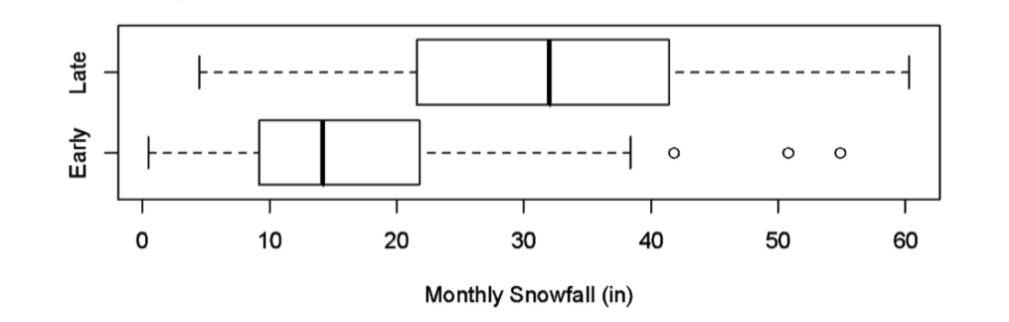
The boxplots demonstrate that there is an association between which two variables?
a. Early and Late winter season
b. Snowfall and months
c. Monthly snowfall and whether the time was Early or Late winter season
d. Whether it was Early or Late winter season and months

